DAY 17
Suricata Rule Writing — Detection Engineering
// 01 OVERVIEW

Day 17 moved from consuming pre-built signatures to writing detection logic directly. Three custom rules were built to cover distinct attack classes: reconnaissance (Nmap SYN scanning), web exploitation (directory traversal), and denial of service (ICMP flood). Each rule was placed in /etc/suricata/rules/local.rules, referenced in suricata.yaml with an absolute path, loaded via the Emerging Threats ruleset alongside a live reload (suricatasc reload-rules), and validated against real triggered traffic in fast.log.
This document is a record of the reasoning behind each rule and the debugging required to get from a written rule to a firing rule — not a restatement of Suricata syntax documentation.

// 02 RULE 1 — NMAP SYN SCAN DETECTION

$ The Rule
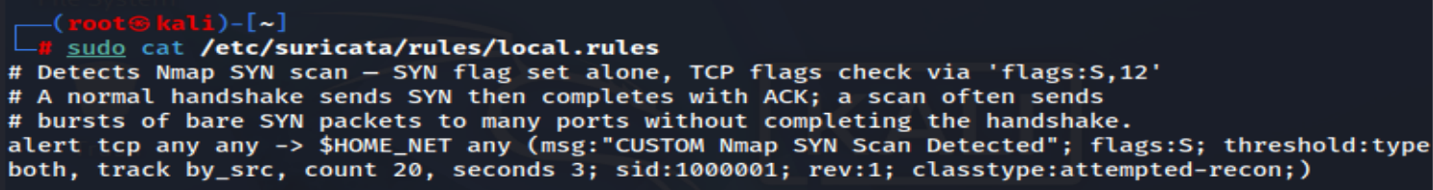
$ Threat Scenario
A SYN scan (nmap -sS) sends a TCP packet with only the SYN flag set to a range of ports, without completing the three-way handshake. A single SYN packet is completely normal — it is the first step of every legitimate TCP connection. What distinguishes a scan from a connection attempt is volume and speed against one destination from one source: dozens of bare SYNs in a couple of seconds is reconnaissance behaviour, not application traffic.
$ What the Rule Looks At
flags:S matches any packet with the SYN flag set, regardless of other flags — this is intentionally broad because the rule is not trying to fingerprint SYN packets, it is trying to count them. The threshold keyword does the actual detection work: type both means fire once per matching window rather than once per packet, track by_src groups the count per source IP rather than globally, and count 20, seconds 3 means the rule only fires once 20 SYNs from the same source arrive within a 3-second window.
$ What This Threshold Means in Practice
20 SYNs in 3 seconds is well above what any normal client generates — a browser loading a page opens a handful of connections, not twenty in three seconds to a single host. It is comfortably below what a default nmap -sS scan produces against even a small port range, since Nmap's default scan probes roughly 1,000 ports in well under two seconds on a local network.
$ What Was Adjusted After Testing
This rule fired correctly on the first test — a full default-range nmap -sS against the Ubuntu Server target crossed the threshold immediately (confirmed in fast.log at 22:08:10, alert 1:1000001:1). No changes were required
// 03 RULE 2 — HTTP DIRECTORY TRAVERSAL DETECTION

$ The Rule (Final — Revision 2)
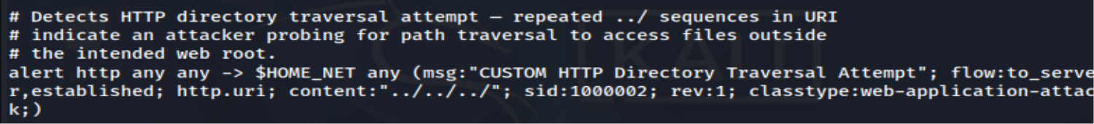
$ Threat Scenario
Directory traversal (path traversal) is an attempt to access files outside a web application's intended root by walking up the directory tree using repeated ../ sequences in the request URI — for example requesting /../../../etc/passwd to reach a system file the application was never meant to expose. It is one of the oldest and still most common web exploitation primitives, frequently the first thing an attacker probes for against a poorly validated file-serving endpoint.

$ What the Rule Looks At
flow:to_server,established restricts inspection to client-to-server traffic on an established connection, so the rule only evaluates actual requests, not responses. content:"../../../" looks for three repeated up-directory sequences — a single ../ is common in ordinary relative linking and not inherently suspicious, but three or more in a row has no legitimate reason to appear in a normal request URI.

$ What Was Adjusted After Testing
This rule did not fire on the first test despite a tcpdump capture confirming the literal string ../../../etc/passwd was present unmodified on the wire (GET /../../../etc/passwd HTTP/1.1). The cause was a buffer choice, not a content match error: http.uri is a normalized buffer — Suricata resolves dot-segment path traversal internally before the content match runs, the same way a browser or reverse proxy would collapse the path before use. Because of that normalization, the literal ../../../ string the rule was searching for no longer existed in the buffer being inspected, even though it existed on the wire.
The fix was to match against http.uri.raw instead — the un-normalized, pre-processing version of the URI buffer that preserves the request exactly as sent. Switching the sticky buffer from http.uri to http.uri.raw (revision bumped to 2) resolved it; the rule fired correctly on the next test, confirmed in fast.log at 22:23:00, alert 1:1000002:2. The practical lesson: when a rule should obviously match based on raw traffic but does not fire, check whether the buffer being inspected is a normalized form of the data rather than the literal bytes sent.

// 04 RULE 3 — ICMP FLOOD DETECTION

$ The Rule
$ Threat Scenario
An ICMP flood sends a high volume of echo request packets at a target in a short window, consuming bandwidth and processing capacity as a denial-of-service technique. A single ping, or even an occasional handful, is routine network diagnostic activity and should never alert. The distinguishing factor is exclusively rate, not content — the packets themselves are indistinguishable from a normal ping.

$ What the Rule Looks At
itype:8 restricts the rule to ICMP echo request packets specifically (type 8), excluding echo replies and other ICMP message types that are not relevant to a flood scenario. As with the Nmap rule, all of the actual detection logic lives in the threshold keyword: type both, track by_src, count 50, seconds 2 means the rule fires once 50 echo requests from the same source arrive within a 2-second window.

$ What This Threshold Means in Practice
50 pings in 2 seconds is far above any interactive or diagnostic use of ping, which typically sends one packet per second by default. It is comfortably below what a flood-mode ping generates, since sudo ping -f -c 200 sent 200 packets in roughly 340 milliseconds during testing — well over 100x the rate needed to cross this threshold.

$ What Was Adjusted After Testing
This rule also fired correctly on the first test. The only issue encountered during the ICMP trigger step was operational rather than rule-related: flood mode (ping -f) requires root privileges to bypass the default 2ms minimum send interval, which the initial attempt was run without. Re-running with sudo resolved it, and the alert fired as expected at 22:08:31, confirmed in fast.log (1:1000003:1).

// 05 VALIDATION EVIDENCE

The following screenshots capture each rule firing in fast.log, showing the alert message, timestamp, and source/destination addresses as required for the Day 17 deliverable.
$ Rule 1 — Nmap SYN Scan
Triggered via nmap -sS 192.168.56.10
$ Rule 2 — HTTP Directory Traversal
Triggered via curl --path-as-is against the traversal payload, post http.uri.raw fix
$ Rule 3 — ICMP Flood

Triggered via sudo ping -f -c 200 192.168.56.10
$ local.rules — Final Contents

